1. Top Categories for Total Price: Observing the bar chart below will reveal the highest-selling product and its revenue. These are the top-rated products in the Nexusgoods Superstore.

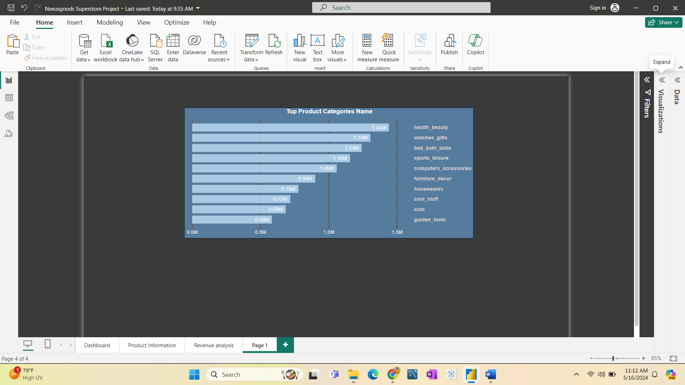

1. Delayed Orders Analysis: It will provide the most delayed orders together with their product names. As we can see below, bed_bath_table had 811 orders delayed across the Nexusgoods Superstore.

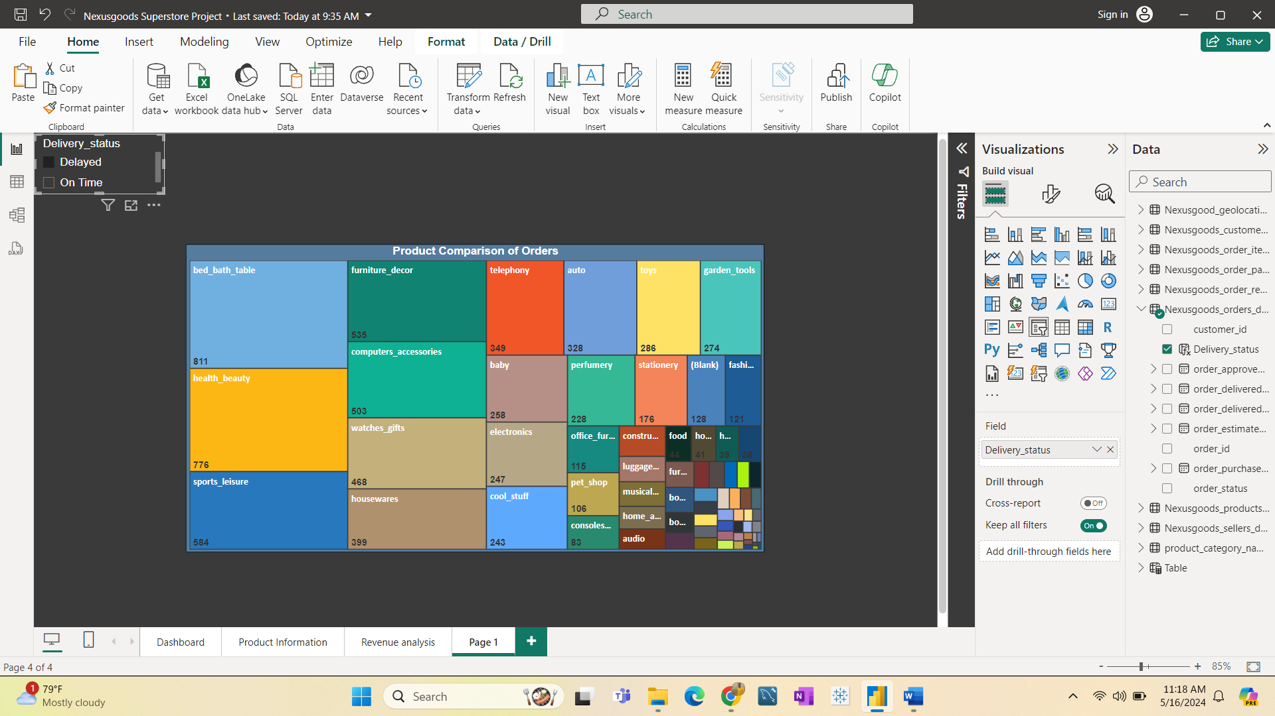

1. Monthly Delayed Order Comparison: This will provide statistics on the number of delayed orders in relation to quarterly sales. In the first quarter of 2018, which includes January, February, and March, a high number of products are being delayed.

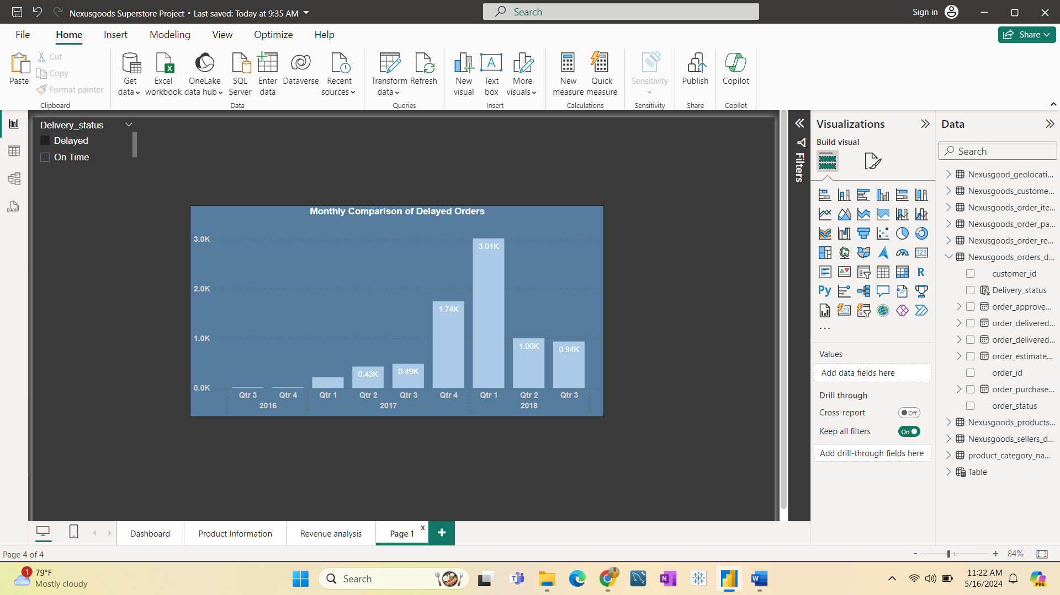

1. Monthly Comparison of On-Time Orders: This graph displays the number of on-time orders in relation to quarterly sales. In the second quarter of 2018, which included April, May, and June, most of orders were delivered on time.

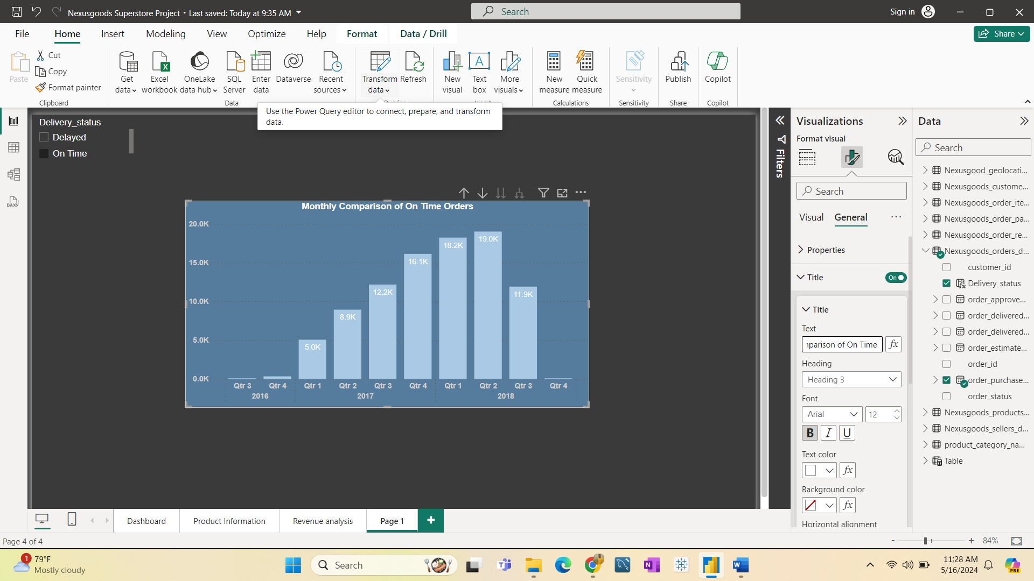

1. **Payment Method Analysis: In this chart observed that customers used various payment methods, including credit cards, debit cards, Boleto, and vouchers.** 74% of clients paid with credit cards, 19% with Boleto, 5% with vouchers, and 1% by debit card.

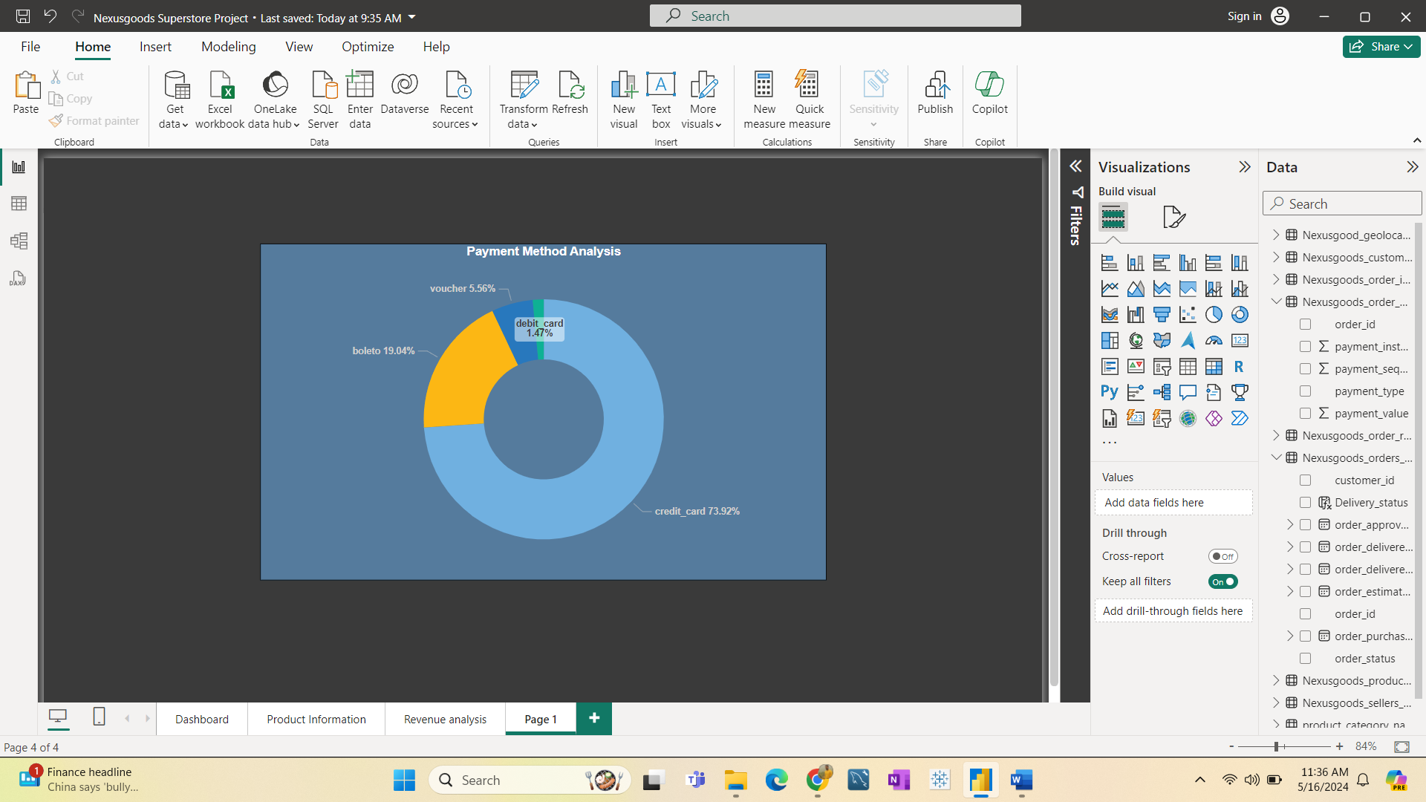

1. Product Rating Analysis: This analysis provides information on the quality of products based on customer ratings at Nexusgoods Superstore. 57% of customers gave a 5-star rating, 19% gave a 4-star rating, 12% gave a 1-star rating, 8% gave a 3-star rating, and 3% gave a 2-star rating.

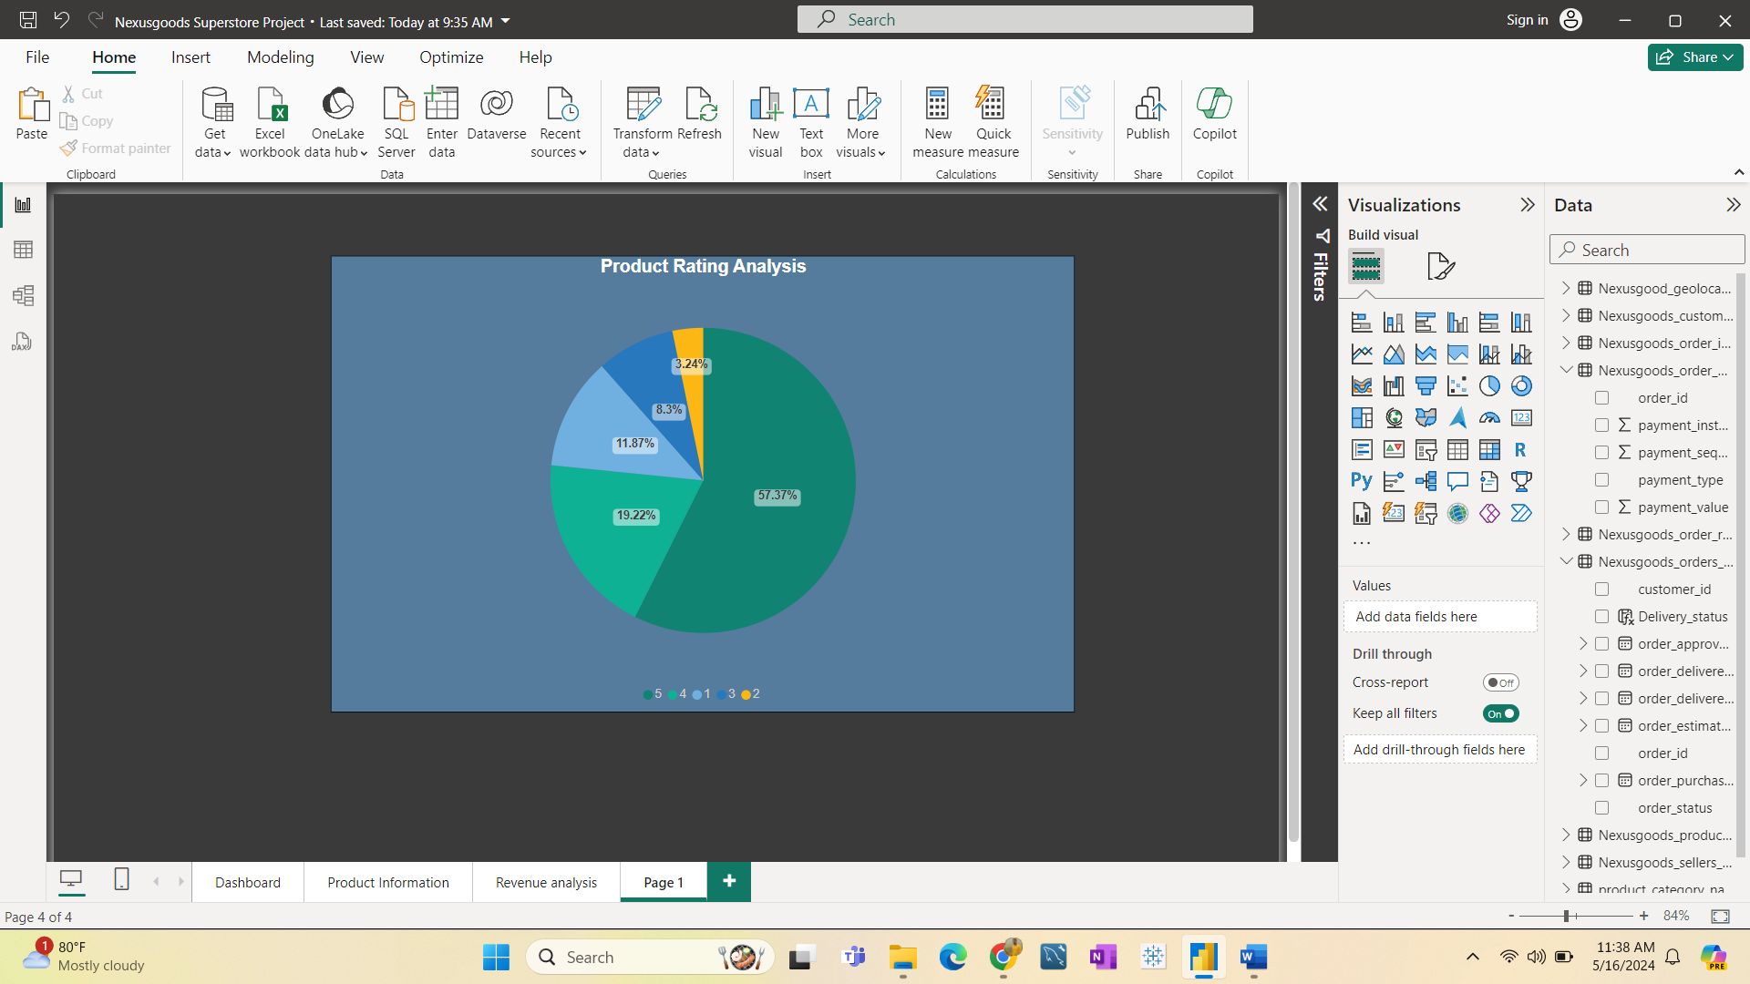

1. Top 10 Highest Rated Products: Based on customer reviews (*****) the top 10 product categories are as follows.

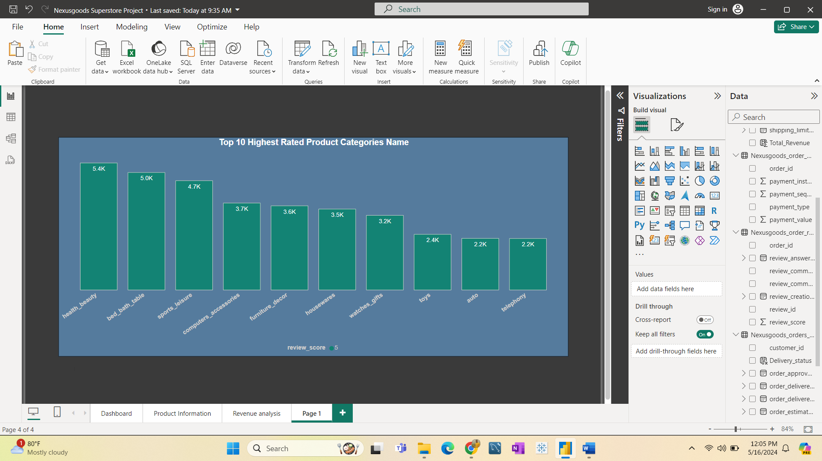

1. Top 10 Lowest Rated Products: Based on customer reviews (*) the top 10 product categories are as follows.

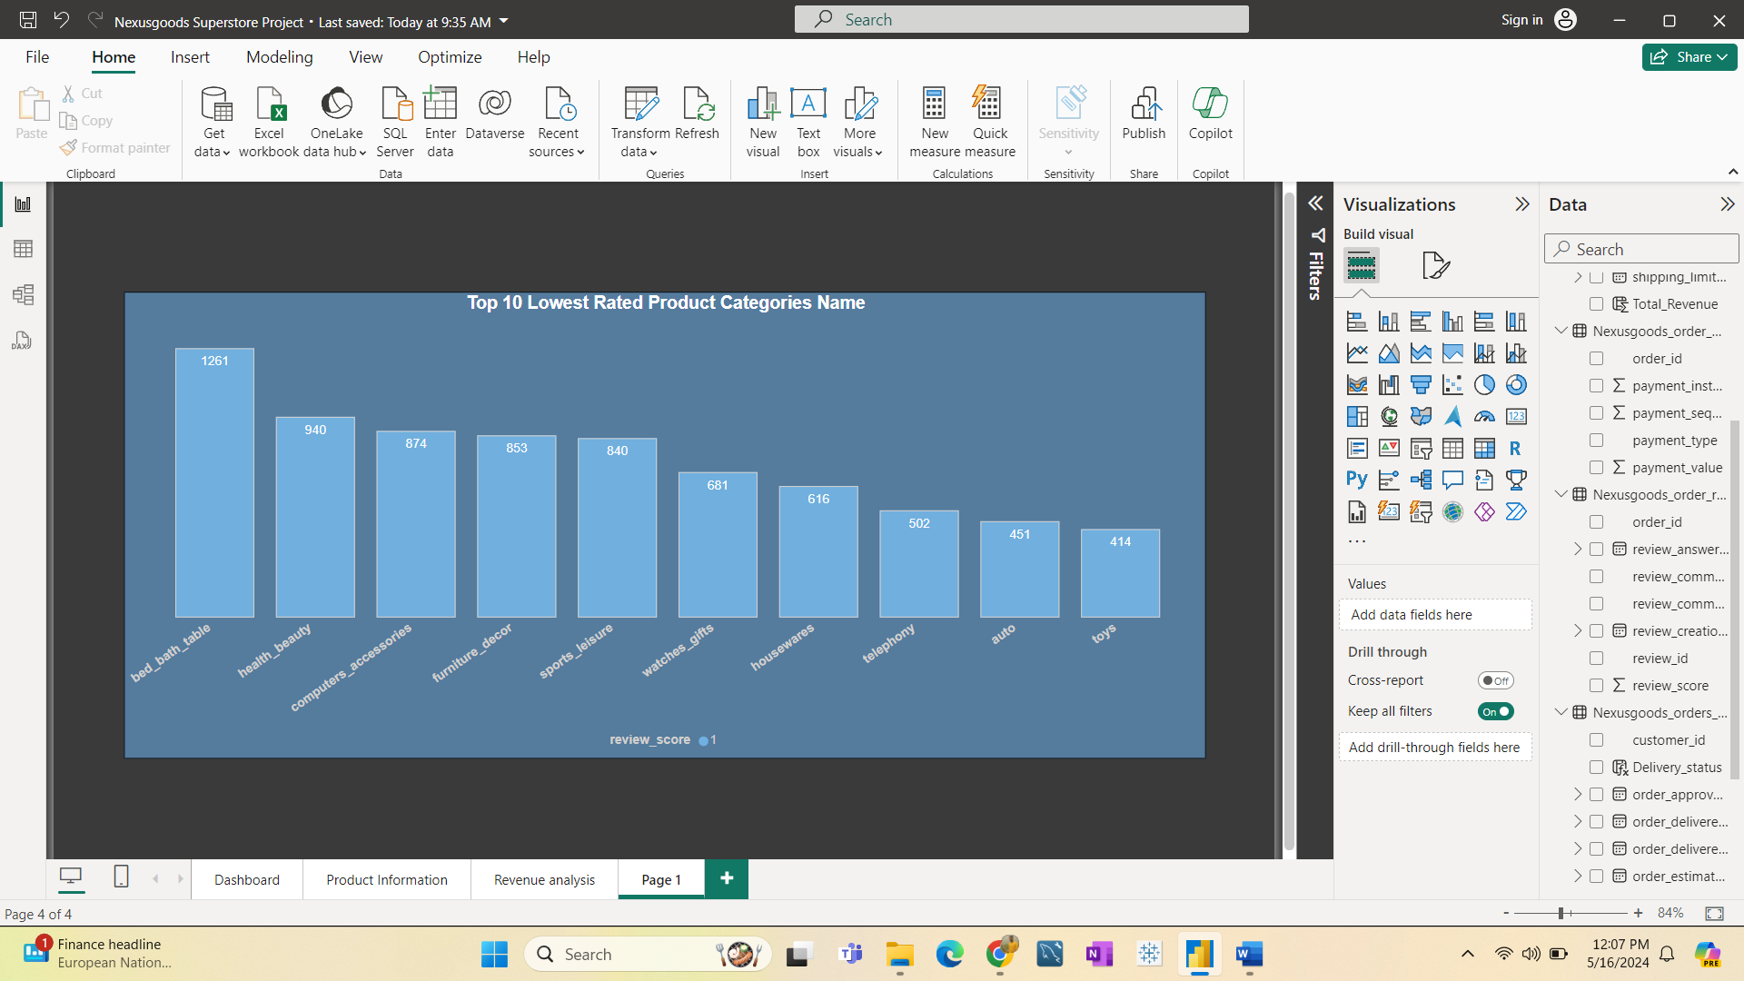

1. State-wise Sales Analysis: This graph displays state-specific revenue; SP had the greatest revenue, while RR had the lowest.

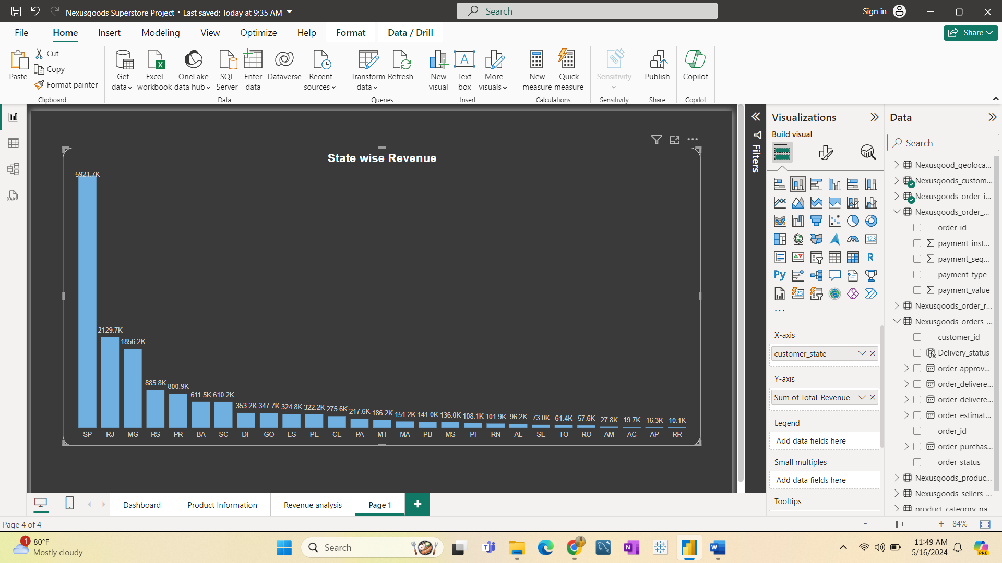

1. Seasonal Sales Patterns: This graph displays information on quarterly sales. The second quarter of 2018 had the most revenue, while the third quarter of 2016 had the lowest revenue.

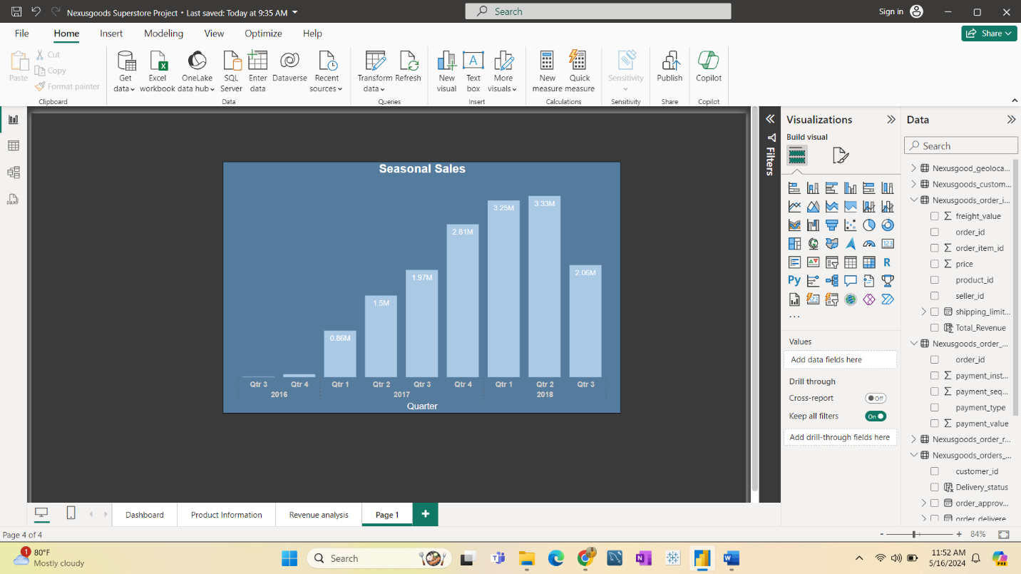

1. Revenue Analysis: This graph displays total revenue over time; by observing this graph, the superstore's revenue has increased year after year.

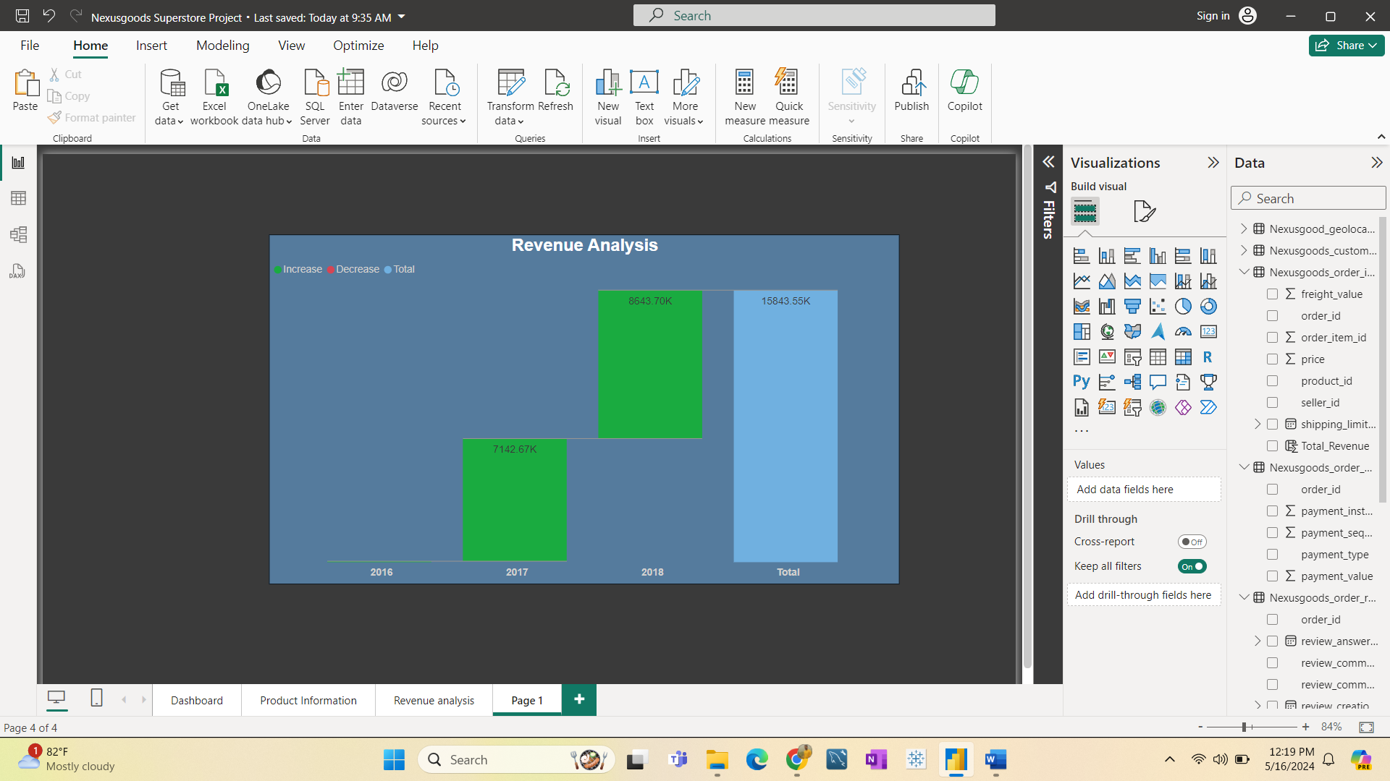

**DASHBOARD REPORT**

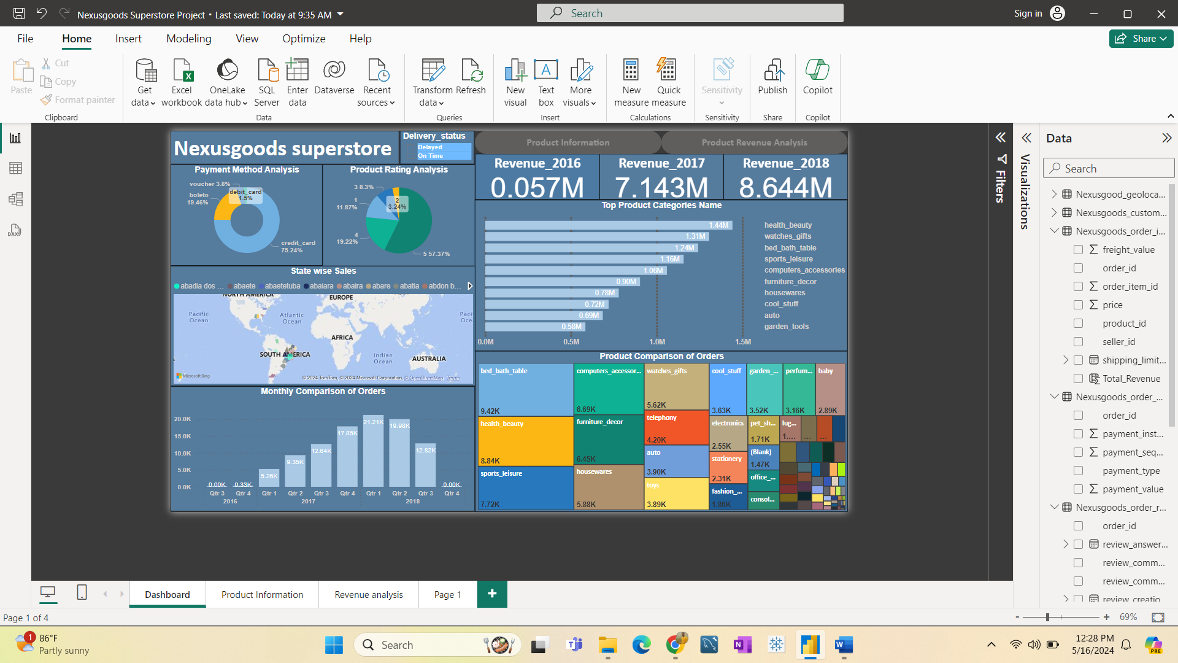

Nexusgoods Superstore Analysis Report

**Introduction:**

This report provides a comprehensive analysis of various aspects of Nexusgoods Superstore, including product ratings, delayed orders, sales patterns, and payment methods. The insights are derived from customer reviews, sales data, and order statistics to offer a detailed overview of the superstore's performance.

* **Top Categories for Total Price**

Observing the bar chart below reveals the highest-selling product categories and their revenue. These are the top-rated products in the Nexusgoods Superstore.

* **Delayed Orders Analysis**

This section provides information about the products with the most delayed orders. Bed, Bath & Table had the highest number of delayed orders, with a total of 811 orders delayed across Nexusgoods Superstore.

* **Monthly Delayed Order Comparison**

This analysis provides statistics on the number of delayed orders in relation to quarterly sales. In the first quarter of 2018, which includes January, February, and March, a significant number of products were delayed.

* **Monthly Comparison of On-Time Orders**

This graph displays the number of on-time orders in relation to quarterly sales. In the second quarter of 2018, which included April, May, and June, most of the orders were delivered on time.

* **Payment Method Analysis**

This chart illustrates the various payment methods used by customers. 74% of clients paid with credit cards, 19% with Boleto, 5% with vouchers, and 1% by debit card.

* **Product Rating Analysis**

This analysis provides information on the quality of products based on customer ratings at Nexusgoods Superstore. 57% of customers gave a 5-star rating, 19% gave a 4-star rating, 12% gave a 1-star rating, 8% gave a 3-star rating, and 3% gave a 2-star rating.

* **State-wise Sales Analysis**

This graph displays state-specific revenue. The state of SP had the greatest revenue, while RR had the lowest.

* **Seasonal Sales Patterns**

This graph provides information on quarterly sales. The second quarter of 2018 had the highest revenue, while the third quarter of 2016 had the lowest revenue.

* **Revenue Analysis**

This graph displays the total revenue over time. By observing this graph, it is evident that the superstore's revenue has increased year after year.

**Conclusion:**

The analysis of Nexusgoods Superstore reveals several key insights:

* **Top-Selling Products**: Certain product categories, such as bed_bath_table is highly popular despite issues with delayed orders.
* **Order Timeliness**: While some months see a high number of delayed orders, other periods, particularly the second quarter of 2018, demonstrate efficient delivery.
* **Customer Preferences**: Credit cards are the preferred payment method, indicating the importance of maintaining secure and efficient credit card processing systems.
* **Product Quality**: A majority of products receive high ratings, though there is a notable percentage of low ratings, suggesting areas for quality improvement.
* **Sales Trends**: Revenue trends show positive growth, with certain periods and states outperforming others.

By addressing areas such as delayed order reduction and quality improvement, Nexusgoods Superstore can continue to enhance customer satisfaction and drive further growth.